Class texts- whole class reading, extracts, thematic books
- Happy Mind, Healthy Me
- My Hero is You
- Virus
- Horrible Science- Deadly Diseases

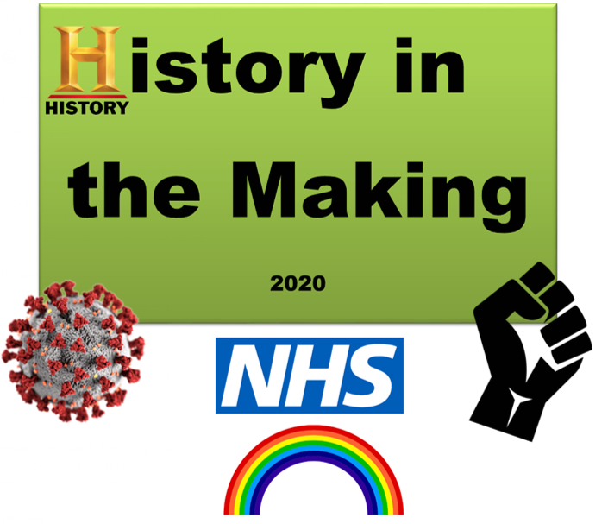
Hooks or memorable experiences

- Collaborative work
- Daily/weekly journaling
- Multiple opportunities for outdoor activities
Year 5/6 History in the Making
Public Product

A collaborative timeline of artwork with all year groups in our school, demonstrating the events of the COVID-19 pandemic.

Cognitive skills / meta-learning – specific teaching examples to use in learning

- CAF- initial idea/ prior knowledge
- PMI- Evaluate subjects/ experiences
- APC- Discussion around alternative outcomes/possibilities
- Collaboration/ planning- learning challenge
- Making links – to help with combining learnt information and experiences in preparation for fair
- Planning – preparing for challenge in a refined manner
Killer Questions- those asked to measure understanding of pupils at key milestone points during the term

- Where does Coronavirus fit into the major events of modern Human history?
- What are the lasting positive changes due to the pandemic?
- How do symbols communicate meaning?
- What are the challenges posed to developing nations?
- Technology- a help or a hindrance?

Year Group |  |  | Term | Autumn | Challenge pack | History in the making
SUBJECT | Children will learn about/ will know WHAT? (Declarative knowledge) |  |  |  | Children will know HOW To…? (Procedural knowledge) | Prior learning (Schemata) | Vocabulary
History | Q: What impact has school closure had on children?  A: Learning, attainment, friendships, mental health (children responses)  Q: What is a pandemic and how do they affect humans?  A: Spanish flu (1918), Black Death, Plague, SARS, MERS, Zika, Ebola – they cause differences to the structure of society and alter the day to day operation of our civilisations.  Q: What is the role of the NHS?  A: The National Health Service is a publicly funded healthcare system that the UK has.  Q- What caused the Black Lives Matter Movement?  Q- How has the world responded to the BLM movement?  Q- How has past history influenced how different groups of people are currently being treated?  Q: How has COVID-19 impacted the Black Lives Matter movement?  A: People had more time to reflect on the actions of American police officers, which was televised, in turn uniting people to protest together. |  |  |  | H3.1a Populate a timeline with key periods including those not studied in depth  H3.1b Demonstrate knowledge of key events in times studied, sequencing these correctly  H3.2a Use a variety of sources to check for accuracy when building a picture of the past  H3.2e Investigate the cause and effect of certain events | Timelines  Basic hygiene  Prejudices and discrimination  Significant moments in modern history | Source  Flu  Virus  Pandemic  Epidemic  Mental Health  Racism
Geography | Q: How have different countries responded to COVID-19?  A: Depending on their location around the world, alongside their economic situation, their culture, a country will respond in various ways – show case studies.  Q: Why have different areas of the UK been affected differently?  A: Population, deprivation,  language barriers and cultures can create different outcomes for regions. |  |  |  | G3.1 a Locate the world’s countries, using maps to focus on Europe (Inc. Russia) and North and South America, concentrating on their environmental regions  G3.1b Name and locate countries and cities of the UK, geographical regions  G3.4a Use maps, atlases, globes and digital/computer mapping to locate countries and describe features studied | Where England is on a map.  Understanding of using digital technology.  How to use an atlas | Border  National  International  Global  Population  Poverty  Economy
Art | Q: What signs and symbols have given us hope in the past and present?  A: Washing hands, NHS, rainbows, BLM and face masks. Religious symbols – anything that the children suggest.  Q: What modern day artists have given us hope?  A: (Depending on year group – to be decided) |  |  |  | A3.1a Make thoughtful observations, compare ideas methods and approaches in their own and selected artists work.  A3.1b Know about and draw inspiration from a range of artists or cultures to influence their own work.  A3.2a Know about and use a range of tools and media to create drawings utilising line and shade with increasing control  A3.5a Adapt work in response to personal and group critique, describing how they will develop it in future.  A3.5b Describe techniques used, evaluating how they could be performed more effectively. (Shading with oil pastels and how to accurately depict a light source onto their drawings) | Knowing that artists are important in our society(KS1)  Select id3eas from a studied artist/art form to use in our own work (KS1)  Using a range of media to experiment with shade (KS1) | Shading  Gradient  Mixed media  Collage
Computing | Q: What sources can we rely on for information?  A: Discern if they have come from reliable sources: are there links to scientific evidence? Is it a politician’s quote?  Q: How can we use technology safely?  A: As children, asking adults for their advice and by being responsible for our choices and decisions when online. |  |  |  | C3.1a Understand computer networks including the internet; how they can provide multiple services.  C3.1b Understand the opportunities for communication and collaboration  C3.2a Select, use and combine a variety of software that accomplish given goals  C3.4a Use technology safely, respectfully and responsibly  C3.4c Use search technologies effectively, appreciate how results are selected and ranked  C3.4d Be discerning in evaluating digital content | Logging on to computer/using iPad  Looking up information using Google or another search engine | Browser  Search engine  URL  Cross check  Verify
Science | Q: Why is handwashing so important?  A: mouldy bread investigation  Q: What is a micro-organism and how are they spread?  A: 3 main types: fungi, bacteria, virus (airborne, water, physical contact) |  |  |  | S3.1a Plan different types of scientific enquiries to answer questions, including recognising and controlling variables where necessary  S3.1e Report and present findings from enquiries, including conclusions, causal relationships and explanations of and degree of trust in results, in oral and written forms such as displays and other presentations  S3.1f Identify scientific evidence that has been used to support or refute ideas or arguments. | Basic handwashing  Food hygiene  Germs | Bacteria  Bug  Cell  Disease  Fungi  Germ  Microbe  Micro-organism  Microscope  Pathogen  Probiotic  Viruses
PSHE | Q: What has been the impact of coronavirus on our health?  A: Impacts of lockdown (mental health implications), lack of exercise, relationships – family and friends becoming ill/not seeing groups of people.  Q: How can we build resilience in times of adversity?  A: Mindfulness techniques (breath work, exercise, awareness). Talking to trusted people about our emotions and learning to recognise them. Questioning why do we feel that way?  Q-Why is the virus impacting BAME communities more?  A-Social economic factors, lack of PPE in the public health sector etc  Q- What has been the impact of COVID-19 on ethnic minority communities within the UK?  A- Emotions that have fuelled by freedom of rights being taken away whilst put in lockdown – More people supporting Black Lives Matter movement.  Q – What are stereotypes, prejudices, discrimination and oppression?  A – Explore terminology and understand how they work and what we can do to break the cycle. |  |  |  | I can describe how times of change can be difficult  I can plan ways to support my peers and self in times of need and develop resilience  I can practice short self-care techniques (e.g. mindfulness, importance of rest, time spent with friends and family, benefits of hobbies and interests)  I can identify when emotions are expressed in healthy and unhealthy ways  I recognise how viruses, bacteria and germs can be spread amongst people and why vaccination is important  Understand the terms discrimination and stereotypes  How to challenge stereotypes relating to race, ethnicity, culture and nationalities. | Emotions  Importance of exercise  Anti-bullying  Community awareness  I can identify what makes me unique  I can recognise that all people are equal, countless of gender, race and life choices  I can consider the different pathways that people might take in life | Diversity  Stereotypes  Discrimination  Oppression  Resilience  Empathy
Music | Q: What impact has colonialism had on music today?  A: Polyrhythmic textures and improvisation changed the way music is performed.  A: Traditional folk songs from the slave trade had an impact on the development of jazz and blues era  A: Music was one of the only ways slaves could communicate freely and was adopted as a way of expressing oneself. |  |  |  | M3.4a I listen to a wide variety of musical genres and comment using a range of musical vocabulary  M3.4b I understand that music often reflects cultural context e.g. celebrations…  M3.4d I listen to a wide variety of music and identify the musical genres.  M3.4e I can use musical vocabulary confidently to describe the music I am listening to. | Listening to and appreciating a range of music by classical, jazz and film composers | Polyrhythmic textures  Colonialism  Folk  Blues  Jazz  Swing  Rap  Pop  R’n’b  Rock and Roll

