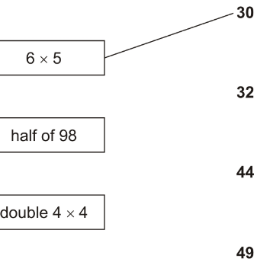
L.O. Multiplication
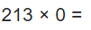
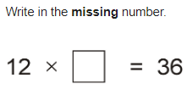
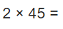
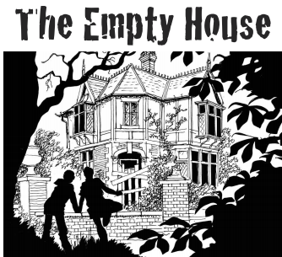
LO write a play script.
Task: Your task is to write a play script continuing the conversation between the friends as they explore the house but discover it is not as
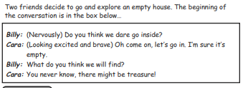
empty as they thought!

Reading - LO to read and answer the retrieval questions.
Opening night
Tim took another deep breath. Inside his chest, he could feel his heart pounding like a bass drum. Again, he took slow, deep breaths and picked up his script. Flicking through the pages, he read through his lines quietly to himself, mumbling under his breath. All his hard work over the last few months had been for tonight. Crossing his fingers tightly, he wished for good luck.
“Tim, are you ready? You’re on in 2 minutes,” said Mr. Smith.
“I think so, Sir,” said Tim in a shaky voice.
“Don’t worry, you’ll be fine, Tim. Break a leg!”
Slowly, Tim stood up and made his way towards the heavy, red velvet curtain. He pulled it to the side and stepped through.

- How do you think Tim is feeling at the beginning of the text?
- Explain how you know how he is feeling.
- What do you think Tim is waiting to do?
- What clues told you what Tim might be doing?
- Who do you think Mr. Smith is?
- Do you think “Opening Night” is a good title? Why?
- If you had to give this text a different title, what would you call it?
L.O. To design an ‘Ancient Roman’ style building.
Draw a picture of a building that would have been built in the Roman times. Make sure you include all the design features (e.g. columns, arches, etc.) that were used during that period of time.
YEAR 4 DAILY TASK 3 COPY AND COMPLETE THE TASKS IN YOUR HOME BOOKS

