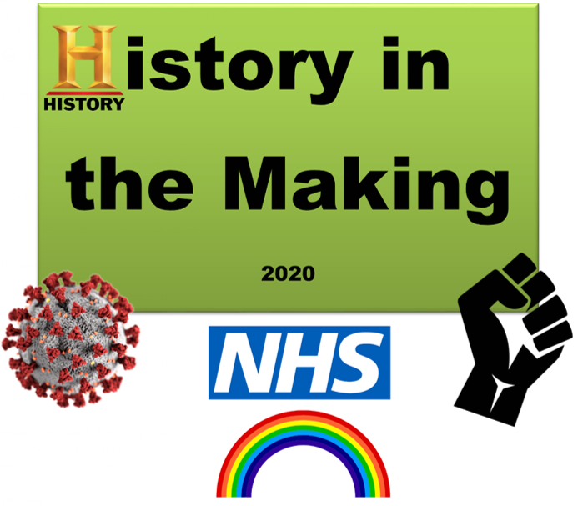
Class texts- whole class reading, extracts, thematic books

- After the Fall – Dan Sanat
- Covid around the world
- Through my window
- You are my hero

Killer Questions- those asked to measure understanding of pupils at key milestone points during the term

- What important events in History can you list?
- How can we prevent germs from spreading?
- How did the world react?
- Why are symbols important and who uses them?

Hooks or memorable experiences
Welcome back
Well being
Mindfulness
Daily/weekly journaling
Multiple opportunities for outdoor activities

Lower KS2 Learning Challenge
Year 3 and 4
Public Product – what will the outcome look like to demonstrate learning?

Creative project- Art
+

Cognitive skills / meta-learning – specific teaching examples to use in learning

- CAF- initial idea/ prior knowledge
- PMI- Evaluate subjects/ experiences
- APC-
- Collaboration/ planning- learning challenge
- Listening
- Absorption-
- Questioning
- Imitation-
Year Group |  | LKS2 | Term | Autumn | Challenge pack | History in the Making
SUBJECT | Children will learn about/ will know WHAT? (Declarative knowledge) |  |  |  | Children will know HOW To…? (Procedural knowledge) | Prior learning (Schemata) | Vocabulary
History | The Role of the school  How have schools reacted in past pandemics?  Historical Pandemics  Timeline of the pandemic world  Timeline of pandemic UK – personal  Add Spanish Flu  What caused the pandemic and what was the impact on society?  What is the ongoing impact of the pandemic?  When was the NHS formed? Who founded the NHS? What is the advantages of having the NHS especially during this pandemic?  BLM  How do we embrace people of different race, religion, culture, gender and age?  What is BLM? Why did it become more prominent recently? How has the world responded? Which communities has it effected and why?  How has past HISTORY influenced how they are treated now? (slavery)  What is slavery? And how has it impacted on people of the world?  SEN: Words of feelings such as ill, matching pictures to the appropriate word. Discussion about what good hygiene looks like.  SEN: Pictures which relate to lockdown routine and a routine for school. |  |  |  | H2.3c Make connections and contrasts over different periods of time  H2.2c Identify and give reasons for historical changes and events  H2.2a Question why some significant features of historical societies still exist today  H2.1d Use understanding of specific time periods to create an identified timeline  H2.2b Use different sources of information to build up specific pictures of the past  PSHE: I can identify what makes me unique  PSHE: I can recognise that all people are equal, countless of gender, race and life choices  PSHE: I can consider the different pathways that people might take in life  SL: I can label a picture appropriately using symbols and words.  SL: I can sequence 2 given events from a story using pictures | H1.3c Identify how significant events or individuals have had impact nationally or globally  H1.2c Start to ask how and why things might have happened in the past  H1.2a Ask questions about what has happened in my own lifetime  H1.1d Sequence key events within a specific time period.  H1.2b Ask questions about what has happened in a time period beyond our lifetime | Source  Flu  Virus  Pandemic  Epidemic  Mental Health  Racism  Timeline
Art/R.E. | What signs and symbols give us hope?  Discuss religious symbols, doves, others?  How did the world react through art?  Explore the reaction of the world through street art.  SEN: Can I match pictures of two different countries in to the correct group recognising similar shapes in the pictures? |  |  |  | A2.1a Record and explore ideas from first hand observation or from experience and imagination  Collage A2.4c Combine and explore texture to create an effect  Drawing A2.2a Know that different media and tools make different marks and use these creatively in their work- Pencil, charcoal, pastel, pen  Printing A2.3d Know that images can be repeat printed using a variety of block and mono printing techniques to make patterns and pictures  Painting A2.3c Know which brushes and tools to choose to work at different scales  PSHE: I can recognise that different people have different beliefs, choices or preferences and that this makes us all individually great  SL: I can match the same pictures together. | A1.1a Themes, observation, artefacts, the world around them  A1.2a Mark making using different drawing materials. | Shading  gradient  Mixed media  Collage
Technology | How did technology help during the pandemic?  The enhanced usage of information technology – calls, videos, face time.  How was information shared and was it always reliable? News headlines, news papers.  What is Zoom? Can we arrange a zoom? |  |  |  | C2.1a Understand the opportunities computer networks offer for communication  C2.4c Identify a range of ways to report concerns about online content  PSHE: I can recognise the dangers of speaking to people online when we don’t know who they definitely are | C1.1a Recognise common uses of information technology beyond school | Browser  Search engine  URL  Cross check  Verify
Geography | Different countries and experiences and responses  Do you have friends and family who live in different countries? How were their experiences similar or different that yours?  Explore stories from around the world with the common thread of kindness/altruism.  How can we plot the rise of Covid? Use maps and timeline to record the spread.  What examples of great leadership were displayed in countries around the world? New Zeeland, U.K, America, Italy  SEN: Can I match pictures of two different countries in to the correct group recognising similar shapes in the pictures? |  |  |  | G2.3b Describe and understand key aspects of: human geography, including: types of settlement and land use, economic activity including trade links, and the distribution of natural resources including energy, food, minerals and water  G2.4a Use maps, atlases, globes to locate countries and describe features studied  PSHE: I can recognise the importance of working together and what this looks like when done well  SL: I can match the same objects/pictures together | G2.1b Name and locate countries and cities of the UK, geographical regions and their identifying human and physical characteristics, key topographical features (including hills, mountains, coasts and rivers), and land-use patterns  G2.4b Use the eight points of a compass, four figure grid references, symbols and key (including the use of Ordnance Survey maps) to build their knowledge of the United Kingdom and the wider world | Countries  Border  National  International  Global  Population  Poverty  Economy
Relationships to core subjects (Maths, English, Science)  PSHE /Citizenship | Personal experiences and consequences of 2020  What are the high and lows of being in lockdown?  How long did lockdown last, and what impact has it had on you and your family?  How did it make you focus on relationships, especially those you missed?  How did effect your feelings and emotions and physical well-being?  Has this experience changed you?  SEN: What you did in lockdown in images  The Positive changes  What new skills have you learnt or things have you tried?  What have we become grateful for?  What has changed for the better?  Is there anything you will keep doing differently?  What is the importance of health and exercise?  What positive effect has this experience had on you?  SEN: Which parts of the body are being exercised when shown a picture of an activity.  SEN: How you felt during lockdown.  People Who have helped us  Who are key workers and how did they help us?  - Clap for carers/NHS /Unsung heroes  SEN: Matching pictures of keyworkers to the correct name e.g. picture of nurse next to the word Nurse.  The role of the school  What did you miss about being at school?  How did you want to come back or not? Why?  SEN: Matching pictures to the days of the week- e.g. ‘M’ next to Monday.  SEN: Ipad selecting images then selecting writing in correct groups. |  |  |  | PSHE3.3e I can discuss the importance of role models in the community  SMSC1.c Can talk and write about my opinions.  SMSC1.f Can describe some of the different beliefs and values in society and demonstrate respect and tolerance towards people who are different from myself.  PSHE  I can practice some more sustained mindfulness in a focused way  I can identify choices that I might make when there is change in my life  I can plan things that I can do to help me feel better if I am finding life hard  I can describe the importance of expressing emotions  I can explain that my mental wellbeing is as important as my physical health  SL: I can say/sign an appropriate word to finish a spoken sentence e.g. I woke up in the …....... Then I had my ….............  SL: I can form a caption using a bank of given symbols/words e.g. My legs work when I ride a bike.  SL: I can try to write a short phrase/caption correctly using the initial sounds/prominent sounds of the words.  SL: I can show you pictures/photos of familiar things.  SL: I am beginning to show that marks and symbols have meaning e.g. scribble writing next to a picture, a pretend shopping list.  SL: I can tell you the difference between letters and pictures | I can identify ways that I could get help if I was in need  I can list a normal range of emotions (happiness, sadness, anger, fear, surprise)  I can show or express my emotions  PSHE2.3e I can consider the different pathways that people might take in life | Emotions  Mindfulness  High/lows  Feelings  Positive  Negative  Rest  Benefits  Healthy  unhealthy
science | What is a virus (germs)? – Germ dispersal experiment.  Why is the covid virus dangerous?  How is it transmitted? The importance of washing hands – investigate the growth of mould on bread.  What measures can be put into place to prevent it?  What is a vaccine and how does work? |  |  |  | S2.1a Ask relevant questions and use different types of scientific enquiries to answer them  S.2.1b Set up simple practical enquiries, comparative and fair tests  S2.1c Make systematic and careful observations and, where appropriate, take accurate measurements using standard units, using a range of equipment, including thermometers and data loggers  I recognise how viruses, bacteria and germs can be spread amongst people and why vaccination is important  PSHE: I practice daily good hygiene (dental and body) and understand how germs can be spread | The importance of hygiene  S1.1a Ask simple questions and recognise that they can be answered in different ways  S2.1c Make systematic and careful observations and, where appropriate, take accurate measurements using standard units, using a range of equipment, including thermometers and data loggers | Bacteria Bug Cell Disease Fungi Germ Microbe Micro-organism Microscope  Pathogen Probiotic  Viruses
Music | Q: What impact has colonialism had on music today?  A: Polyrhythmic textures and improvisation changed the way music is performed.  A: Traditional folk songs from the slave trade had an impact on the development of the jazz and blues era  A: Music was one of the only ways slaves could communicate freely and was adopted as a way of expressing oneself. |  |  |  | M2.4a I listen to a wide variety of musical genres for longer periods.  M2.4d I listen to a wide variety of musical genres and deliberate the composer or genre of the piece.  M2.4e I can comment on music using the interrelated dimensions of music vocabulary | Listening to and appreciating a range of music by classical, jazz and film composers  M1.4a I can listen to a variety of music and describe it in simple terms e.g. fast, slow, loud, and soft.  M1.4d I can identify the pulse of a piece of music | Folk  Blues  Jazz  Swing  Rap  Pop  Rnb  Rock and Roll

