Year 3 Copy and Complete
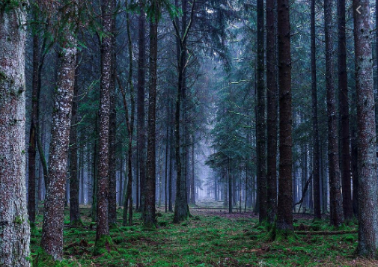
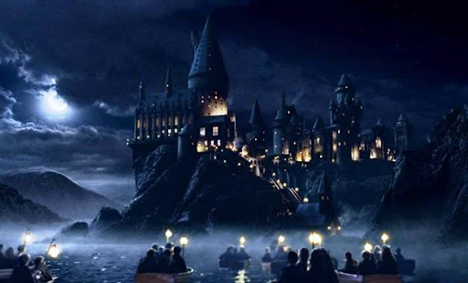
English-
Pick a picture or create one of your own to describe the scene. Use the prepositions, expanded noun phrases and similes you have worked on the past few days.

Reading
Draw the main character in the book your reading. Can you describe and label them? What do they look like? What is their character like? What hobbies do they have?
Maths-Subtraction
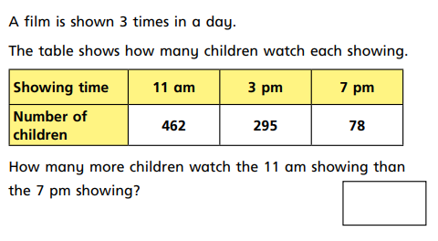
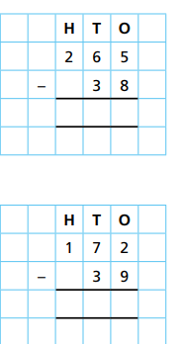
https://app.mymaths.co.uk/1721-lesson/introducing-column-subtraction (You could use this lesson to help)

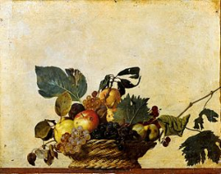
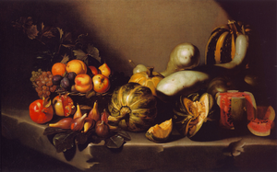
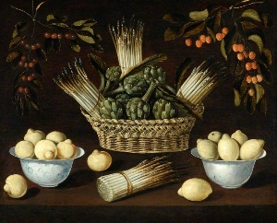
Art

Choose one of the Caravaggio paintings above and see if you can create a similar image. You could choose to sketch something still-life around the house e.g. a plant, an apple etc.
Top sketching tips: easydrawingtips.com

