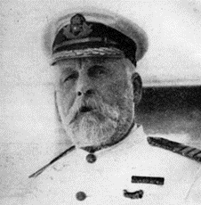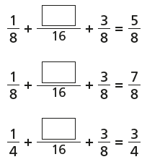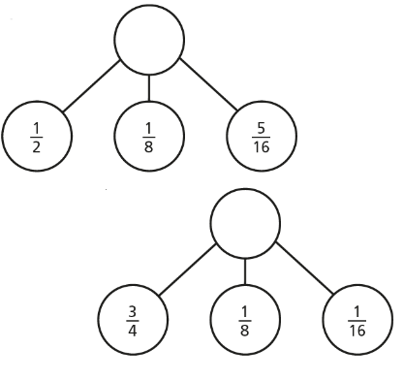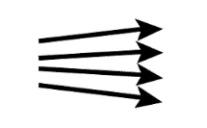

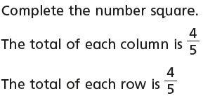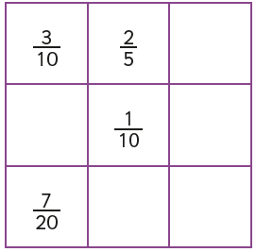

Edward Smith – Captain (died)

I was a highly experienced captain. In fact, I even helped to avoid a disaster in Southampton as the Titanic set sail! The size of the ship meant that when it moved forward, it sucked a smaller boat towards it. It was thanks to me that we swerved out of the way in time!

The only reason we were travelling so quickly when we hit the iceberg was because the water was so calm and the sky so clear. My wireless operator did mention that there was ice in the area, but it is usually much smaller than the berg we hit. If I’d have known, I’d have slowed down, of course!

When we sank, I helped as many women and children into boats as I could. The last anyone saw of me was helping a child into a boat, then drifting away into the icy waters...

Thematic: History

Consider alternatives, possibilities and choices (APC) by reading through a crew member’s testimony and suggest what he could have done differently to avoid loss of lives.

He rose upright in the stirrups. He scarce could reach her hand,

But she loosened her hair in the casement. His face burnt like a brand

As the black cascade of perfume came tumbling over his chest;

And he kissed its waves in the moonlight,

(O, sweet black waves in the moonlight!)

Then he tugged at his rein in the moonlight, and galloped away to the west.

Reading

**R – What does the Highwayman *try* to reach?**

**R – What does Bess so that he can show he loves her?**

**V – Which word closely matches ‘cascade’?**

A: A large amount of

B: Smelly

C: Darkness

**I – What makes you think that the two characters are in love?**

Writing

Diary Writing Toolkit: Using the past tense, including opinions as well as facts, uses personal pronouns (I, me, we), describes the writer’s point of view, thoughts and feelings.

Task: Rewrite the second paragraph of the diary entry making improvements.

When the Queen came, it was good. The Queen was very polite. The Queen made everybody feel good. The Queen spoke to all of us.

Maths: Add 3 or more fractions with different denominators

Lesson: <https://app.mymaths.co.uk/91-lesson/adding-subtracting-fractions>

1. 2. 3.

Year 5 - Day Six – Please copy and complete in your book.