Year 3 Copy and Complete
English-
Edit and improve the short setting description below. Check spelling, grammar and punctuation. Can you improve the adjectives? Can you add prepositions? Can you add similes?

the muddy path leads up to the forest. the grond is filled with puddles. Spikey grass covers the floor of the forest. Towering high are big trees? Birds twitter as they swoop in the air above.

Reading
Read the next 5 pages of your book. Can you answer these questions about your book. What is the main character doing? How do they feel? What do you think will happen next? Why?
Maths-Multiplication
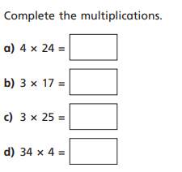
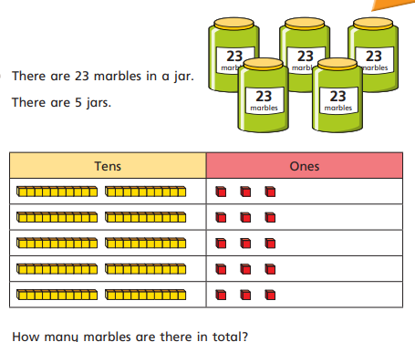
https://app.mymaths.co.uk/1725-lesson/short-multiplication (You could use this lesson to help)

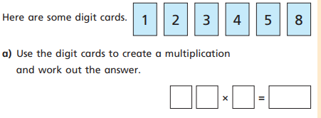
D.T and Geography
Create a food diary for today. It could include pictures and recipes.

Breakfast=
Lunch=
Tea=
Snacks=

Can you find out where in the world the foods you have eaten come from? E.g. pizza is from Italy

