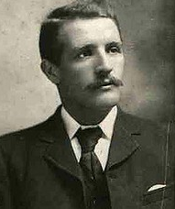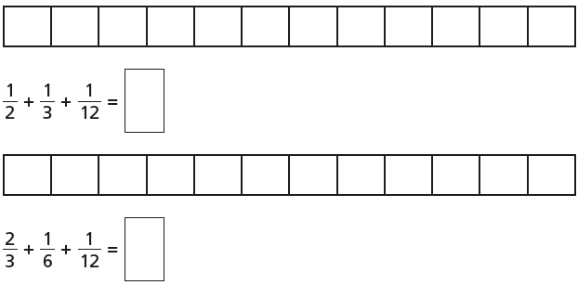

William Murdoch – Chief Officer (died)

I was on the bridge when the call came through – “iceberg right ahead!” I immediately ordered the ship to turn starboard (left) in the hope that we would avoid hitting it. I then sent a call through to the engine room, telling them to reverse the engines to slow us down. I closed all of the watertight doors below decks to seal any punctured compartments.

There are some people who think that if we had hit the iceberg straight on, it would only have damaged the front of the ship and we’d stay afloat. But my training has always taught me to try to avoid hitting icebergs.

Maybe if I hadn’t reversed the engines, we would have turned quicker, I don’t know! But I did everything I could.

Thematic: History

Consider alternatives, possibilities and choices (APC) by reading through a crew member’s testimony and suggest what he could have done differently to avoid loss of lives.

“One kiss, my bonny sweetheart, I’m after a prize to-night,

But I shall be back with the yellow gold before the morning light;

Yet, if they press me sharply, and harry me through the day,

Then look for me by moonlight,

Watch for me by moonlight,

I’ll come to thee by moonlight, though hell should bar the way.”

Reading

**R – What is the Highwayman finding?**

**R – What time of day will he be back?**

**V – Which word closely matches ‘bonny’?**

A: Ugly

B: Happy

C: Beautiful

**I – What tells us that he is committing a dangerous act?**

Writing

Which is the most appropriate pronoun for the sentences below?

a) Poppy was unable to see the key that **she/her** needed to open the door.

b) Fatima wanted to leave **her/she** party because it was beginning to get dark.

c) The walls of the castle were crumbling and ivy had begun to cover **them/it**.

d) He was starting to feel nervous so he rang **her/mine** friend.

Write 4 sentences using appropriate pronouns.

Maths: Add 3 or more fractions with different denominators

Lesson: <https://app.mymaths.co.uk/91-lesson/adding-subtracting-fractions>

1. 2.

3.

Year 5 - Day Five – Please copy and complete in your book.