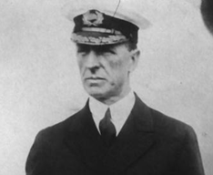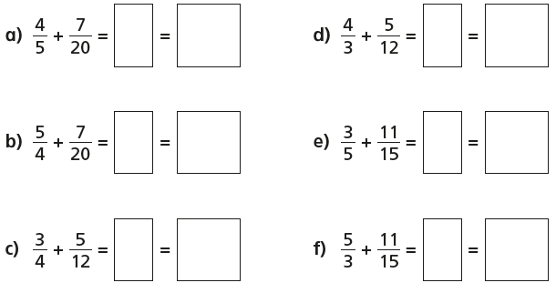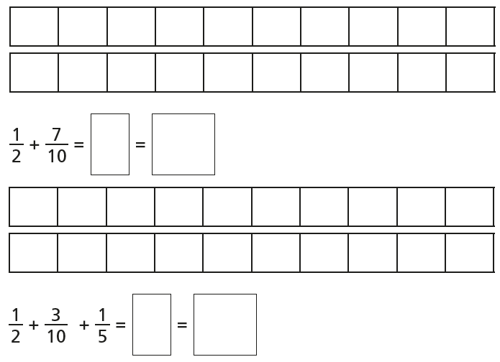

Thematic: History

Consider alternatives, possibilities and choices (APC) by reading through a crew member’s testimony and suggest what he could have done differently to avoid loss of lives.

Stanley Lord – Captain of S.S. Californian (Captain of a different ship)

We had stopped our ship, the S.S. Californian, for the night because the sea was filled with pack ice.

Before we went to bed, our telegraph operator sent a message to a large ship about ten miles away, warning it that there was ice about. It was the Titanic. They told us to stop messaging them, as they had a backlog of messages to send to passengers’ relatives in New York.

Later that night, my Second Officer noticed rockets being fired from the Titanic. He tried to signal using a flash light, but got no response. We never thought to switch the radio on. Several more rockets were fired, and the ship did look rather strange. Then, gradually, it seemed to disappear, as though it was sailing away... I decided to try to get in touch with them in the morning.

I didn’t know it had sunk, otherwise I would have helped!

PART TWO

He did not come in the dawning. He did not come at noon;

And out of the tawny sunset, before the rise of the moon,

When the road was a gypsy’s ribbon, looping the purple moor,

A red-coat troop came marching—

Marching—marching—

King George’s men came marching, up to the old inn-door.

Reading

**R – When did the King’s men come to the inn?**

**R – What word is repeated for dramatic effect?**

**V – What colour is similar to ‘tawny’?**

A: Grey

B: Orange

C: Blue

**I – What do you think has happened to the Highwayman?**

Writing

Diary Writing Toolkit: Using the past tense, including opinions as well as facts, uses personal pronouns (I, me, we), describes the writer’s point of view, thoughts and feelings.

Task: Write the second paragraph of a diary entry.

Use what you have written in writing lessons at school to write the second paragraph to your diary entry.

Remember to include everything in the toolkit, especially emotive language (describe feelings). It will help to look back at the improvements you made to yesterday’s paragraph.

Maths: Add fractions with different denominators, convert into mixed numbers

Lesson: <https://app.mymaths.co.uk/91-lesson/adding-subtracting-fractions>

1. 2.

Year 5 - Day Seven – Please copy and complete in your book.