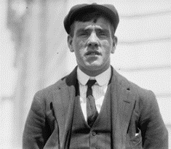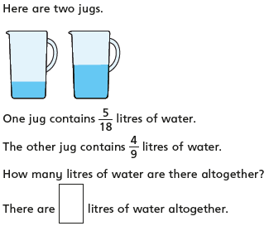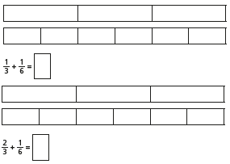

Year 5 - Day Three – Please copy and complete in your book.

Frederick Fleet – Look Out (survived)

It was nearly midnight. I was on the night shift in the crow’s nest. The sea was as smooth as a pond and the sky brilliant with stars. It was freezing. All I could see was my breath. I didn’t have my binoculars because they’d been locked in a cupboard and no-one knew where the keys were.

Suddenly, I spotted the towering grey mountain of ice dead ahead. It came out of nowhere. I would have seen it sooner if I’d had a pair of binoculars!

I rang to the bridge as fast as I could. “Iceberg, right ahead!” I shouted down the telephone. And then I waited. The ice berg was only a mile away. There was nothing I could do now. I braced myself against the mast for the collision.

Thematic: History

Consider alternatives, possibilities and choices (APC) by reading through a crew member’s testimony and suggest what he could have done differently to avoid loss of lives…

Over the cobbles he clattered and clashed in the dark inn-yard.

He tapped with his whip on the shutters, but all was locked and barred.

He whistled a tune to the window, and who should be waiting there

But the landlord’s black-eyed daughter,

Bess, the landlord’s daughter,

Plaiting a dark red love-knot into her long black hair.

Reading: The Highwayman

**R – What does the Highwayman do to get Bess’s attention?**

**R – What is Bess doing with her hair?**

**V – How is ‘black-eyed’ describing Bess’s eyes?**

A: Frightening

B: Beautiful

C: Bruised

**I – What does the ‘red love-knot’ symbolise? Explain.**

Writing

Diary Writing Toolkit: Using the past tense, including opinions as well as facts, uses personal pronouns (I, me, we), describes the writer’s point of view, thoughts and feelings.

Task: Write the introduction of a diary entry.

Use what you have written in writing lessons at school to write the introduction to your diary entry.

Remember to include everything in the toolkit. Think about how the beginning of a diary entry appears. It will help to look back at yesterday’s task.

Maths: Add and Subtract Fractions with Different Denominators

Lesson: <https://app.mymaths.co.uk/91-lesson/adding-subtracting-fractions>

1. 2. 3.