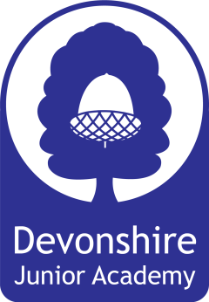
Devonshire Junior School – Aims For Our Pupils

By the time our pupils leave us to move on to secondary school we intend that our curriculum equips them with the following knowledge, skills and personal qualities.
Knowledge
We want our pupils to acquire a broad range of knowledge as a result of our broad and balanced curriculum with an emphasis on a growing general knowledge of the world. We also want them to develop self-knowledge including a growing understanding of their own strengths and weaknesses.
Skills
We want our pupils to have good social and verbal communication skills and the skills necessary to work well with others. In addition to this, we want to ensure they have good English, Maths and ICT skills relevant to a modern world and the skills necessary to think critically.
Personal Qualities
We aim to develop hard-working, self-confident, ambitious individuals who have positive attitudes, enquiring minds and resilience. Our pupils will have a strong sense of right and wrong and be respectful and tolerant of others.

